Tax Invoice

**Invoice Number:** I2923TE001469789 **PacketID:** 9317181023 **Order Number:** 1217099-1167182-4242201 **Invoice Date:** 08 Oct 2022 **Nature of Transaction:**Intra-State **Order Date:** 08 Oct 2022

**Place of Supply:** KARNATAKA **Nature of Supply:** Goods

**Bill to / Ship to:**

# Sraban Kumar

Amaravati PG GENTS, 101D first floor

Brookfield Mall, Behind HP Petrol Bunk Kundalahalli Bengaluru - 560037 KA, India

**Customer Type:** Unregistered

**Bill From: Ship From:**

Tech Connect Retail Pvt Ltd

M/S Aditya Birla Fashion and Retail Limited, Madura Fashion &Lifestyle Division, Located at Sy No. 517/2, 527, 528, 529, 530, 531 of Madivala Village, Kasaba Hobli, Anekal Taluk, Bengaluru, Karnataka- 562107

**GSTIN Number:** 29AAICA4872D1ZK

Tech Connect Retail Pvt Ltd

M/S Aditya Birla Fashion and Retail Limited, Madura Fashion &Lifestyle Division, Located at Sy No. 517/2, 527, 528, 529, 530, 531 of Madivala Village, Kasaba Hobli, Anekal Taluk, Bengaluru, Karnataka- 562107

Qty Gross Amount

Discount Other Charges

Taxable Amount

CGST SGST/ UGST

IGST Cess Total Amount

**LSPLTRSR60346564 - Louis Philippe Men Grey Textured Super Slim Fit Formal Shirt, Size: 32 HSN: 62034300, 6.0% CGST, 6.0% SGST/UGST,**

1 Rs 2599.00 Rs 962.00 Rs 0.00 Rs 1461.60 Rs 87.70 Rs 87.70 Rs 1637.00

**TOTAL Rs 2599.00 Rs 962.00 Rs 0.00 Rs 1461.60 Rs 87.70 Rs 87.70 Rs 1637.00**

# Tech Connect Retail Pvt Ltd

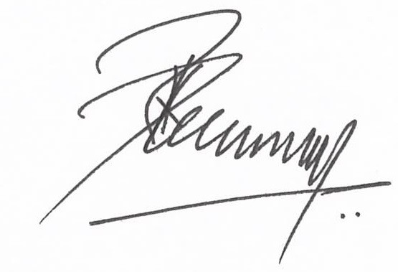

Authorized Signatory

**DECLARATION**

The goods sold as part of this shipment are intended for end-user consumption and are not for retail sale

**Reg Address:** Purchase made on

Tech Connect Retail Pvt Ltd,5A/19,Ground Floor ( Front Portion),Ansari Raod,Daryaganj, , Delhi, Delhi-110002

If you have any questions, feel free to call customer care at **+91 80 6156 1999** or use **Contact Us** section in our App, or log on to [**www.myntra.com/**](http://www.myntra.com/) **contactus**